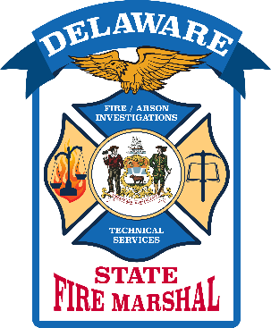

Office of the State Fire Marshal – Delaware

Michael G. Chionchio
Assistant State Fire Marshal
(302) 739-3312 Office Direct Line
(302) 593-9002 Cell

June 29, 2022

The Delaware Office of the State Fire Marshal reminds all citizens and visitors in Delaware that most consumer fireworks are illegal to possess and use. Sparklers and novelty items are permitted to be used only on July 4, 2022. Fireworks that shoot into the air and explode are illegal and not permitted to be used at any time. Firecrackers and bottle rockets are prohibited.

Aerial display fireworks are only permitted to be used by a licensed professional firework shooter. Areas used for aerial display fireworks are inspected and issued permits for the display to occur. Several conditions must be met for a permit to be issued including a minimum distance of 200 feet from any structure and roadway. Larger mortar shells require additional distancing.

Municipalities throughout Delaware will be sponsoring professional firework shows on July 4, 2022. Leave the fireworks in the hands of the professionals.

